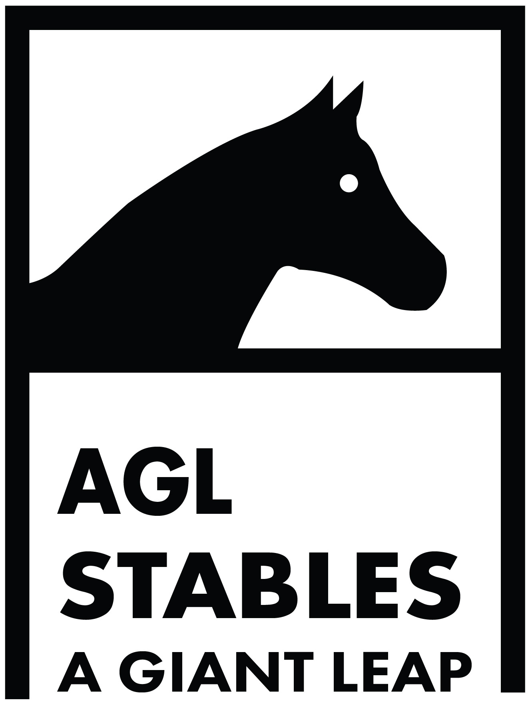
PROSPECTUS
AGL JUMPING &REGIONAL EQUESTRIAN LEAGUE
OCTOBER 19th& 20th2019

AGL REGIONAL EQUESTRIAN LEAGUE PROSPECTUS

General

1.The AGL Regional Equestrian League 2019 will be conducted from October 19th to October 20th2019and will be conducted as per the rules of the Equestrian Federation of Indian at AGL Stables / ARG Stables, Chattarpur, New Delhi
2. Entry fees and stabling charges for riders participating in AGL Regional Equestrian League 2019 and AGL Jumping:
Entry fees: INR 500 plus GST per event for REL
Stabling charges: INR 1000 including taxes per horse per day
ADMINISTRATION

3. Venue. All events will be held at The AGL Stables, B-7 Farm, Bhatti Kalan, Chhatarpur, New Delhi - 110074. Route chart of the same is attached.
Google maps –https://goo.gl/maps/M8nyH1e1sw62
(Note: The venue will open on October 18th 2019 at 1800 hrs.)

4. Camp.All horses will be stabled at The AGL Stables, Chhatarpur. Stableswill be allotted by the organizing committee to all teams depending on the number of horses per team. All horse handlers are permitted to stay along with the horses in temporary accommodation earmarked for the same. All teams are requested to share the number of horses/ handlers per contingent, which are likely to come latest by October 15th 2019 with the show secretary via E-mail.
Charges – Rs. 1000 including taxes per stable per day.
Camp In charge:Jatin - +919953123086, Vijender - +919999967819, Ravi - +919873848180

5.Self-containment. In addition to the above all teams must be self-contained in terms of tentage, equipment for camping and transport in order to be prepared for any unforeseen emergency.
6.Ration /Fodder; All teams should bring their own feed, hay, bedding, grass, etc. for their horses and should make their own provision for staff food. AGL stables will not provide any assistance for the above unless special facilities are being provided for all teams.
7. Coggin’s and Glanders Test; All rules and instructions issued from the EFI on this subject will be strictly adhered to by all participating teams. All teams must produce a valid negative EIA and Glanders status certificate on arrival with a validity of a minimum of 15 days on arrival.
8. Veterinary commission The Veterinary Commission detailed by AGL Stables / ARG Stables for AGL Regional Equestrian League will have the right to examine all the horses participating.
9. Veterinary Assistance.Dr. Vikram Malhotra is the official VET for all AGL Stables shows. Mobile - +919871490564. The charges will be borne by the horse owners.
10. Medical cover. The organizing committee shall not accept any liability for medical treatment given to a competitor on the venue or the consequences there of. Each rider participating in the AGL Regional Equestrian League will fill the Indemnity Bond attached as and submit the same along with entry form.
11. Insurance. The organizing committee recommends units/club/associations to take insurance policies for competitors, personnel, grooms and horses for their transportation to AGL Stables and during the conduct of the events. The organizing committee will assume no responsibility for any accident or illness due to fall of any horse, competitors, groom/ any other member of the team.

12. Responsibility. The organizing committee accepts no responsibility for any loss, damage or injury to any animal or any other property or the exhibitors themselves.
13. Clearance Certificate.Horse owners are required to obtain clearance certificate from the OC during work hours. All concerned accounts need to be cleared before they can obtain the same. No horses/ Person will be allowed to leave by the Camp In-chargewithout the clearance certificate.
14. Correspondence.
- Allcorrespondencepertainingtothecompetitionwillbeaddressedto:

Show Secretary
AGL Regional Equestrian League (AGL REL)
C/O AGL Stables, B7 farms, Bhatti, Chattarpur, New Delhi - 110074
Show secretary: Inderjeet Singh: +919811195462
Asst. to show secretary: Abhishek Chopra: +91.9811.711.213
Email: aglstables@gmail.com
15. Note: The organizing committee may at any time alter/ amend any of the above conditions owing to unforeseen circumstances.

TECHNICAL INSTRUCTIONS

16. Technical Guidelines.

(a) Show Jumping - Refer EFI Website.

(b) Dressage - Refer EFI Website.

(c) Amendments - Refer EFI Website.

(d) Tent Pegging - Refer EFI Website.

17. Schedule of Tentative Events for AGL REL. Refer attached schedule.

18. Entries.

(a) All entries will be on proper Entry Form as attached for the AGL Regional Equestrian League and should be completed in all respect. Entries not on the prescribed entry form will not be considered.
(b) Entry Fee: INR 500 plus GST per event for REL
(c) Closing date for EntriesAll entries forthe AGL Regional Equestrian League will close by October 17th 2019. Entries received thereafter will not be accepted under any circumstances.
(d) Description and Registration of Horses; All entries must give the description, EFI Registration/Passport/Show Number, name and year of birth of the horse concerned.
19. EFI Horses Passport.

As per EFI rules all horses participating inthe AGL Regional Equestrian League events must have a valid EFI passport in original. Entries will not be accepted without the EFI Registration/Passport/Show Number of the horse.
20. EFI Rider Registration.
(a) All riders participating in the AGL Regional Equestrian Leaguemust have a valid EFI Rider Identification Number.
(b) Riders not having EFI rider ID No. will not be permitted to participate.
21. Grading of Horses; It will be the responsibility of the participant to ensure that their horses are entered in the correct grade as per the latest updated list. Entries of the horses in the wrong grade will lead to elimination from that event and disqualification from the entire horse show.
22. Withdrawal, Change, Transfer or Substitutions of Entry.
(a) Withdrawal;The entry fee of a horse will not be refunded if the horse does not participate in the class.
(b) Transfer and Substitutions. A horse cannot be transferred from one class to another without paying an additional entry fee for the class to which is transferred. A horse once entered in any event cannot be substituted by another horse for any reason whatsoever.
(c) Change of Riders; Riders cannot be changed unless the Jury accepts that there are sufficient reasons for change of riders. All changes willbe treated as FreshEntries. Once an event has started, being judged, no change in rider / horse will be accepted.
(d) Technical specification of events; the events will follow broadly the technical guidelines of FEI and EFI as per relevant discipline. However, the organizing committee reserves the right to amend technical specifications for various events keeping in consideration prevalent weather conditions and local merits / climate in consultations with EFI.
23. Cancellation or reschedule; The Organizing committee may cancel or reschedule any class which has less than four entries or for any reason at their discretion. In that case, the entry fee will be refunded. However, depending on the numbers of entries received, the organizing committee may decide against this for any particular event.
24. Reporting for Each Class; All horses will report to the collecting ring Steward half an hour before the time of judging of the class. Any entry not reporting in time will be eliminated unless the exhibitor shows good cause for the delay. The Ring Steward has full authority to take disciplinary action.
25. Show Number. All horses will display the EFI Registration Number on the bridle during competition and veterinary inspection and whenever taken out of the stable under the saddle.
26. Abuse/ Cruelty to horses. Refer to Article 13 of EFI Technical guidelines
27. Rosettes; A horse will wear no rosettes during judging.

28. Elimination / Disqualification; the judges are empowered to disqualify the competitors at any stage of the competition for rough handling, or any type of cruelty to animals. Rapping will be severely penalized. Refer to article 243 FEI Rules for Jumping Events 2009.
29. Whips/spurs; As per EFI and relevant FEI rules per discipline.
30. Dress code; when inspecting the course, dress must be neat and tidy. In any case, riding boots, white breeches, white or lightly colored plain shirts, white tie and Jacket must be worn. Service personnel will be in uniform. It is compulsory for anyone jumping a horse to wear a properly fastened hard hat with a three-point retention harness including riders in uniform.
31. Appeal; any competitor can lodge an appeal two hours before the commencement of any class and within half an hour after announcement of the result. A fee of Rs 2000/- (Rupees two thousand only) should be deposited with the org secretary along with the objection in writing. Money will be refunded if the objection is upheld.

ROUTE MAP TO AGL STABLES

DELARATION (INDEMNITY BOND)

1.I,______________________________________________________________________ resident of ______________________________________________________________ desirous to participate in the AGL Regional Equestrian League 2019/ AGL Jumpingat AGL Stables, Chhatarpur, New Delhi hereby undertake and agree: -
(a) That horse riding and all equestrian sports are inherently unpredictable and potentially dangerous.
(b) That only some basic provisions for medical treatment are made at the event venue and I am responsible for my safety equipment.
(c) That the Equestrian Centre has various unsupervised areas that may be generally risky.
(d) That in the event of any loss or injury to property or person including injury resulting in death I may suffer while participating, I or any other legal representatives shall not hold the AGL Stables / ARG Stablesresponsible for the same or for any consequence thereof.
2. If any rights exist by operation of law, I hereby waive them and undertake not to initiate any action against the AGL Stables / ARG Stablesother persons.
3. It is further declared that stamp duty payable on this undertaking shall be borne by me.

_______________________ _____________________________
(Signature of Witness) (Signature of the Participant)

AGL JUMPING/REL
STABLES REQUEST FORM – TEMPORARY STABLING
OCTOBER19TH AND 20TH 2019

NAME OF RIDER:

NAME OF CLUB:

NUMBER OF HORSES:

NUMBER OF STABLES REQUIRED:

NUMBER OF DAYS INTENDED TO RENT THE STABLES:

AMOUNT: INR 1000per stable per day.
(First cum first serve basis)

TOTAL AMOUNT:

(RIDERS NAME AND SIGNATURE) DATE:

AGL REGIONAL EQUESTRIAN LEAGUE 2017
TENTATIVE PROGRAM SCHEDULE

Saturday, October 19st 2019

S No | Time | Event | Venue
1. | 1500h | REL Children 2 Show Jumping | Arena 1
2. | 1600h | REL Children 1 Show Jumping | Arena 1
3. | 1700h | REL Junior Show Jumping | Arena 1

Sunday, October 20nd 2019

S No | Time | Event | Venue
1. | 1500h | REL Novice Show Jumping | Arena 1
2. | 1600h | REL Grade III Show Jumping | Arena 1

Note: The OC has the right to cancel / amend the date or time of any of the events without any prior intimation / communication.

ENTRY FORM
AGL JUMPING & REGIONAL EQUESTRIAN LEAGUE 2019

NAME OF THE UNIT/INDIVIDUAL/EXHIBITOR: ____________________________________________________________________________________________________
S NO | EVENT | RIDER |  |  | HORSE
S NO | EVENT | NAME | DOB | EFI ID | HORSE NAME | EFI Passport/Regst. NO | COLOR | SEX | DOB

Mobile No_______________________________ Email address________________________________________________________
Note: Entries will not be accepted without Horse EFI Passport No and Rider ID Number

Signature_______________________

